### A MINOR PROJECT REPORT

on

**AUTONOMOUS CAR USING ARDUINO**

*Submitted in partial fulfillment for the award of the degree*

of

## BACHELOR OF TECHNOLOGY

in

## ELECTRICAL AND ELECTRONICS ENGINEERING

by

**VIKRAMAN G (RA2011005010068)**

**NARENDHIRAN S (RA2011005010075)**

**DINESH M(RA2011005010091)**



## FACULTY OF ENGINEERING AND TECHNOLOGY

SRM Nagar, Kattankulathur- 603 203 Chengalpattu District.

### NOVEMBER 2023

**BONAFIDE CERTIFICATE**

Certified that this project report titled **“AUTONOMOUS CAR USING ARDUINO”** is the bonafide work of **NARENDHIRAN S (REG. NO. RA2011005010075), VIKRAMAN G (REG. NO. RA2011005010068), DINESH M (REG. NO. RA2011005010091)** who carried out the project work under my supervision. Certified further, that to the best of my knowledge the work reported herein does not form part of any other project report or dissertation on the basis of which a degree or award was conferred on an earlier occasion on this or any other candidate.

Signature of the Faculty In charge Signature of the Course Coordinator

### Dr. UTHRA.R Dr. UTHRA.R

Assistant Professor (Sr. G) Assistant Professor (Sr. G)

Department of EEE Department of EEE

SRM IST SRM IST

Internal Examiner External Examiner

Date:

# ACKNOWLEDEMENT

First and foremost, we wish to express our sincere gratitude and grateful acknowledgement to the Management of **SRM INSTITUTE OF SCIENCE AND TECHNOLOGY**, for providing us the opportunity to do this project. We express our heartfelt and sincere thanks to our respected **Dr.C.Muthamizhchelvan**, **Vice Chancellor** and **Prof.T.V.Gopal, Dean (CET)**, for their encouragement towards the growth of research work and providing vital resources in the university.

We take this opportunity to express sincere thanks and a deep sense of gratitude to our beloved **Dr.K.Vijayakumar, Dean / Professor and Head of the Department** for his encouragement towards the completion of the project.

We would like to thank our minor project in charge Dr. Uthra.R for her support, knowledge, and valuable input throughout our project. We are deeply grateful for the help, valuable guidance, suggestions, and support.

NARENDHIRAN S

VIKRAMAN G

DINESH M

**ABSTRACT**

The project's main goal is to create a concrete example of the principles of autonomous vehicle technology by designing and developing an Arduino autonomous car prototype. The Arduino microcontroller, a variety of sensors, and a basic control algorithm are used in this educational project to demonstrate the fundamental ideas of autonomous navigation, obstacle avoidance, and path tracking. The goal of this project is to emphasize the use of technology as a teaching tool while providing a foundation for comprehending the complex parts and functions of self-driving cars. Although the prototype has limitations, its purpose is to serve as a foundation for future advancements and improvements in autonomous vehicle technology. The one element that sets Tesla apart from the competition is its fully automated self-driving capability. Not only is the name intriguing, but the technology that powers it is even more so. It has several benefits that support the name and is not only about luxury. We find it astounding that, so few Indian automakers are concentrating on this technology extensively. In light of this, this paper proposes to construct a model of a self-driving autonomous car that is minimalistic in nature and focuses on three primary functions: detecting stop signs and stopping for five to ten seconds; operating in accordance with the environment based on the direction of the road; and detecting traffic signs and making decisions based on them; and detecting the two-lane path and carrying out the aforementioned functions. Keywords: Autonomous Vehicles, Self-driving car, Computer Vision, Image processing, wireless sensor networks, control systems, path planning.

### TABLE OF CONTENTS

|  |  |  |
| --- | --- | --- |
| **CHAPTER** | **TITLE** | **PAGE** |
|  | **ABSTRACT** | **iv** |
|  | **LIST OF FIGURES** | **vii** |
| **1** | **INTRODUCTION** | **8** |
|  | 1.1 BRIEF OVERVIEW OF THE PROJECT | 8 |
|  | 1.2 BACKGROUND AND SIGNIFICANCE | 9 |
|  |  |  |
| **2** | **PROJECT OBJECTIVES** | **10** |
|  | 2.1 AUTONOMOUS CAR PROTOTYPE OVERVIEW  2.2 DEFINING SPECIFIC PROJECT OBJECTIVES | 10  11 |
| **3** | **HARDWARE EXTRACTION** | **13** |
|  | 3.1 INTRODUCTION |  |
|  | 3.2 HARDWARE COMPONENTS | 13 |
| **4** | **DRIVING INTELLIGENCE** | **18** |
| **5** | 4.1 SENSOR SELECTION AND INTEGRATION  4.2 MOTOR CONTROL  4.3 OBSTACLE AVOIDANCE ALGORITHM  4.4 LINE FOLLOWING ALGORITHM  **WIRELESS MANAGEMENT & POWER SUPPLY**  5.1 INTRODUCTION  5.2 UTILIZING BLUETOOTH MODULE  5.3 ENERGIZING AUTONOMY  5.4 BATTERY SETUP  5.5 CHALLENGES IN POWERING  AUTONOMOUS CAR | 18  19  21  23  **26**  26  28  30  31 |

|  |  |  |
| --- | --- | --- |
| **6**  **7** | **PERFORMANCE AND RESULT**  6.1 TESTING METHODOLOGY  6.2 ISSUES ENCOUNTERED AND RESOLUTIONS  6.3 PERFORMANCE RESULTS  6.4 CODING  6.5 CHALLENGES AND FUTURE IMPROVEMENTS  **CONCLUSION**  7.1 IMPROVEMENTS AND FUTURE WORKS  7.2 VISION FOR THE NEXT STEPS  7.3 CHARTING THE PATH AHEAD  **REFERENCES** | **33**  34  35  36  40  **41**  42  43  **44** |

**LIST OF FIGURES**

|  |  |  |
| --- | --- | --- |
| **FIGURES**  1.1  2.1  2.2  3.1  3.2  3.3  3.4  3.5  3.6  4.1  4.2  5.1  5.2  5.3  5.4  6.1  6.2  7.1 | **TITLE**  Autonomous car prototype  Circuit diagram  Flow chart for working of the car  Arduino UNO ATmega328p  Ultrasonic sensor hc-sr04  Infrared sensor  L298N motor driver  Shaft BO motor  Servo motor SG-90  Block diagram of sensor methodology  Motor driver module  Bluetooth Waveform Generation and Transmission  Spectrum  Bluetooth module hc-06  Circuit Diagram of the Design  Tackling the Challenges of the Autonomous car  Flow Chart of the system  Levels of automations and its characteristics  Future works | **PAGE**  8  10  12  14  15  15  16  16  17  18  20  27    29  31  34  35  42 |

**CHAPTER 1**

**INTRODUCTION**

* 1. **BRIEF OVERVIEW OF THE PROJECT**

The "Autonomous Car using Arduino Prototype" project aims to design and develop a small-scale self-driving car using Arduino microcontrollers and various sensors. This project is a hands-on exploration of autonomous vehicle technology, providing an educational opportunity to understand the fundamental concepts of robotics, automation, and sensor integration. Key project components include an Arduino microcontroller, sensors (such as ultrasonic, infrared, and/or cameras), motors for movement, and a power supply system. The autonomous car prototype is programmed to navigate its environment, make decisions, and perform specific tasks, such as obstacle avoidance or line following.

The project's objective is to demonstrate the capabilities and limitations of a simple autonomous system, making it an excellent learning exercise for students and hobbyists interested in robotics and automation. Throughout the project, you'll learn about sensor integration, motor control, and the implementation of algorithms for tasks like obstacle avoidance and line following.

The project's goals include creating a functional autonomous car, developing the necessary code and algorithms, testing its performance, and possibly identifying areas for future enhancements. By the end of this project, you'll have a deeper understanding of autonomous systems, which can serve as a foundation for more advanced and sophisticated autonomous vehicle projects.

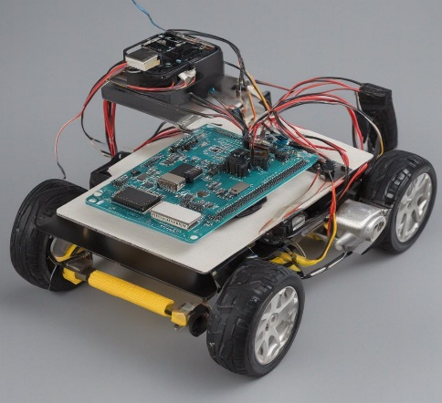

**1.1 AUTONOMOUS CAR PROTOTYPE**

* 1. **BACKGROUND AND SIGNIFICANCE**

Autonomous cars hold significant importance in the modern world due to their potential to revolutionize transportation. These vehicles promise to make our roads safer by drastically reducing the number of accidents caused by human error. With their ability to communicate and navigate independently, they can also alleviate traffic congestion and reduce fuel consumption, making transportation more efficient and environmentally friendly. Moreover, autonomous cars offer increased mobility and accessibility for people who are unable to drive, enhancing their quality of life. Beyond individual benefits, this technology can reshape urban planning, reduce the need for extensive parking infrastructure, and create new economic opportunities. As autonomous technology advances, it has the potential to transform how we move, work, and live, ultimately leading to a safer, more efficient, and interconnected transportation ecosystem.

Arduino plays a fundamental role in our project to develop an autonomous car prototype. As the project's central nervous system, Arduino's versatility is invaluable, enabling the integration of various sensors, actuators, and control logic required for autonomous navigation. The open-source nature of Arduino provides access to a vast repository of libraries, code examples, and a supportive community, simplifying the implementation of complex algorithms for obstacle detection, path planning, and vehicle control. Its user-friendly IDE facilitates programming, allowing us to easily write, upload, and modify code. Additionally, Arduino's compatibility with a wide array of sensors, cameras, and communication modules makes it the ideal platform to collect and process real-time data, crucial for decision-making and ensuring that the autonomous car operates efficiently and safely. Overall, Arduino offers a cost-effective, scalable, and education-friendly solution for bringing our autonomous car project to life.

**CHAPTER 2**

**PROJECT OBJECTIVES**

**2.1 AUTONOMOUS CAR PROTOTYPE OVERVIEW**

The primary objectives of our autonomous car prototype project are to create a self-driving vehicle capable of autonomous navigation and task execution. Our prototype will integrate a variety of sensors, such as ultrasonic, infrared, and cameras, to perceive its environment, identify obstacles, and make informed decisions. Specifically, the car will be programmed to perform obstacle avoidance, enabling it to detect and safely maneuver around objects or obstructions in its path. Furthermore, it will feature a line-following capability, allowing it to autonomously trace and adhere to predefined paths or road markings. Our project seeks to demonstrate the practical implementation of these autonomous features, leveraging Arduino as the control hub to process sensor data and execute control algorithms. By achieving these objectives, our autonomous car prototype will showcase the potential for real-world applications of autonomous vehicle technology and serve as an educational tool for exploring the foundations of robotics and automation.

The primary objectives of our autonomous car prototype project encompass the creation of a self-driving vehicle designed to exhibit sophisticated autonomous navigation capabilities. Our prototype will integrate an array of sensors, including ultrasonic, infrared, and to perceive and interpret its surroundings in real time. One key objective is to implement obstacle avoidance, enabling the vehicle to detect and respond to obstacles or impediments in its path by making quick and safe decisions, thus enhancing safety, and preventing collisions. Another pivotal goal is to establish line-following functionality, wherein the autonomous car will be programmed to track and adhere to pre-defined paths or road markings, showcasing precise control and directional accuracy. Our project is oriented towards the practical application of these autonomous features, with Arduino serving as the central control unit responsible for processing sensor data and executing control algorithms. In achieving these objectives, our autonomous car prototype aims to serve as a tangible embodiment of the potential for autonomous vehicle technology in real-world scenarios, all the while providing a valuable educational platform for the exploration of fundamental concepts in robotics and automation.

**2.1 Circuit Diagram**

**2.2 DEFINING SPECIFIC PROJECT OBJECTIVES**

Our project entails several specific goals aimed at creating a fully functional autonomous car prototype. First and foremost, we are determined to implement obstacle avoidance capabilities, enabling the vehicle to autonomously identify and navigate around obstacles, thereby enhancing road safety. Additionally, we seek to incorporate line-following functionality, allowing the car to accurately trace and adhere to predefined paths or road markings, showcasing precision control. Another vital objective is the integration of wireless communication for remote control and data monitoring, offering real-time interaction. Moreover, we aim to achieve efficient power management to ensure uninterrupted operation, considering energy consumption and battery setup. Testing and troubleshooting will be a critical aspect of our project, where we'll thoroughly evaluate the performance of our prototype and address any issues encountered during development. Ultimately, our project is underpinned by these specific goals, each contributing to the creation of a robust and educational autonomous car prototype.

There are several crucial sub-objectives that will guide the development of our autonomous car prototype. These include the seamless integration of a variety of sensors (ultrasonic, infrared, cameras, and possibly LIDAR) to enable comprehensive environmental perception. We aim to develop real-time decision-making algorithms that can rapidly process sensor data and guide the car's responses for obstacle avoidance and line following. Precise maneuvering is another key focus, ensuring that the car can navigate with accuracy, accounting for factors like turning radius and wheel speed. The implementation of a user-friendly interface for remote control is crucial, allowing operators to monitor the car's status and intervene when necessary. Data logging capabilities will be integrated to record and analyze performance and sensor data during test runs. Safety mechanisms, including emergency stop protocols and sensor failure handling, are imperative. Additionally, we plan to provide comprehensive user documentation to facilitate replication and understanding, prioritize expandability and customization, define specific performance metrics, and consider an educational outreach component to share the knowledge and inspire others to explore autonomous vehicle technology. These sub-objectives collectively enrich the project's depth and its potential impact.

**2.2 Flowchart for working of the car.**

The basic condition for movement of the car will be distance which will be sensed with the help of ultrasonic sensor. So, we will be specifying the distance according to which, it will decide to move forward, backward, left, right or stop. The degree of freedom of the ultrasonic sensor is increased with the help of servo motor since the ultrasonic sensor is mounted on the servo motor. So, the ultrasonic sensor will also sense the distance to its left and right and change the path accordingly.

**CHAPTER 3**

**HARDWARE EXTRACTION**

**3.1 INTRODUCTION**

Components used in this project.

1. Bread board
2. Arduino UNO
3. IR Sensor
4. L298 Motor Driver
5. Mini Servo Motor SG90
6. Ultrasonic Sensor Holder
7. Ultrasonic Sensor hc-sr04
8. Shaft BO Motor
9. Smart Robot Car Tyres Wheels
10. Bluetooth module
11. Male to Female jumper Wires
12. Male to Male jumper Wires
13. On/Off Switch, 18650 Battery Holder – 2 Cell
14. 18650 Battery Cell 3.7V.

**3.2 HARDWARE COMPONENTS**

**ARDUINO UNO**

Selecting the Arduino Uno as the heart of our autonomous car project stems from its reputation for user-friendliness and widespread popularity in the maker and education communities. As we embark on this challenging endeavor, having a microcontroller platform that is easy to understand and program is invaluable, especially for those new to electronics and robotics. The abundance of online resources, tutorials, and a supportive community surrounding the Arduino Uno will be instrumental as we tackle complex tasks like sensor integration and real-time control. Moreover, its cost-effectiveness aligns with our project's educational focus, allowing us to keep expenses manageable while gaining practical experience in autonomous systems development. The expandability and ample digital and analog pins of the Arduino Uno offer the flexibility we need to connect the various components required for autonomous navigation, making it an excellent choice to oversee the sensory input and control output. In essence, the Arduino Uno not only equips us with the technical capabilities to drive our project but also promotes learning, experimentation, and innovation—a pivotal factor in our decision.

The Arduino Uno is one of the most popular and widely used Arduino boards. It is based on the ATmega328P microcontroller. It has 14 digital input/output pins (of which 6 can be used as PWM outputs), 6 analog input pins, Clock speed of 16 MHz Sufficient for basic autonomous car projects with limited sensors and actuators. Also Cheaper compared to other Arduino Boards.

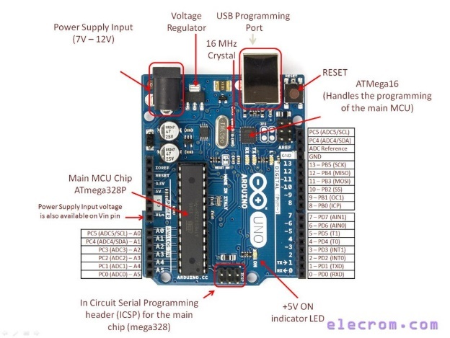

**3.1 Arduino UNO ATmega328p**

Other types of Arduino boards are also there, such as

**Arduino Mega** – larger board compared to ATmega328p type, suitable for more complex autonomous car projects like big projects.

**Arduino Due** – Powerful board which is used to Advanced level of autonomous car projects.

**Arduino Nano** – This board is made for Space-constrained projects.

**Arduino MKR** – These boards are suitable for remote-control, Data transmission or cloud connectivity.

**ULTRASONIC SENSOR (hc-sr04)**

The ultrasonic sensor assumes a pivotal role in our autonomous car project by serving as the eyes and ears of the vehicle. Its primary function is obstacle detection, as it emits high-frequency sound waves and analyzes their return time to calculate the distance to objects in the car's path. This real-time data is instrumental for ensuring the car's safety by allowing it to identify obstacles and make rapid decisions, such as altering its path, reducing speed, or stopping to avoid collisions. The ultrasonic sensor forms a critical component of our vehicle's sensory perception system, contributing significantly to its autonomous navigation capabilities and enhancing overall safety during operation.

An ultrasonic sensor is an instrument that measures the distance to an object using ultrasonic sound waves. Ultrasonic sensors are commonly used for obstacle detection. Multiple sensors placed around the car can provide a 360-degree view of the surroundings. By constantly sending and receiving ultrasonic waves, the car can detect obstacles and determine their proximity, helping it navigate safely.

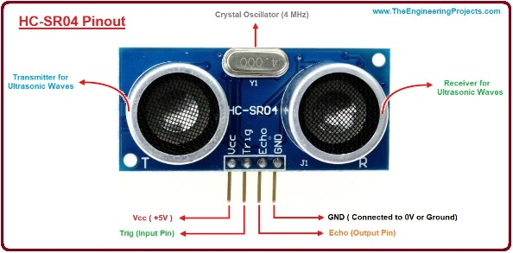**3.2 Ultrasonic Sensor hc-sr04**

Range – 2cm to 400cm. Voltage – 5v

Frequency = 40kHz for hc-sr04

**INFRARED SENSOR (IR)**

In an autonomous car prototype with an Arduino, Infrared (IR) sensors are essential components for various crucial functions. IR sensors serve as the car's eyes, allowing it to perceive its surroundings and make safe navigation decisions. They detect obstacles by emitting and measuring the reflection of infrared light, enabling the vehicle to determine the distance to obstructions and avoid collisions. Additionally, IR sensors are valuable for tasks such as line following, proximity sensing, and parking assistance. These sensors can help the car stay on course by following marked lines, detect nearby objects and pedestrians to prevent accidents, and facilitate precise parking. In an autonomous car project, programming the Arduino board to process IR sensor data and make informed decisions is a fundamental aspect of the development process. While a full-fledged autonomous vehicle requires a combination of sensors and sophisticated computing, IR sensors on an Arduino prototype provide a foundation for understanding and experimenting with autonomous vehicle technology.

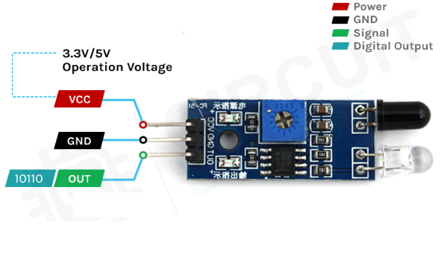

**3.3 Infrared Sensor**

**L298 MOTOR DRIVER**

The L298 motor driver plays a pivotal role in enabling precise and flexible motor control. This versatile component provides the means to control the movement of DC motors, which is particularly valuable in robotics, mechatronics, and automation projects. The L298's dual H-bridge configuration empowers the project with the ability to control two motors independently, allowing for dynamic movements, including forward, reverse, and braking. By interfacing with a microcontroller or control system, the L298 receives signals to determine motor direction and speed, making it an essential bridge between the digital world of commands and the physical movement of the motors. With its bidirectional control, current sensing capabilities, and compatibility with logic signals, the L298 ensures the project's motors can be precisely manipulated for tasks ranging from robot navigation to conveyor belt operation, thereby contributing to the project's overall functionality and performance.

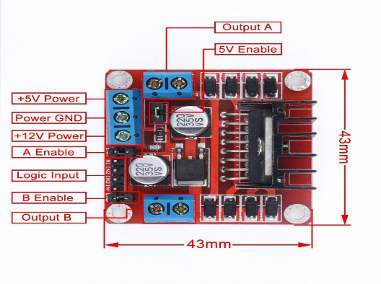

**3.4 L298N Motor Driver Module**

**SHAFT BO MOTOR**

A Shaft-BO motor, also known as a Brushed DC (Direct Current) motor with a shaft output, plays a fundamental role in driving mechanical motion and providing the project with the capability to perform various tasks. These motors are highly versatile and are employed in a wide range of applications, including robotics, automation, and DIY projects. The Shaft-BO motor serves as the mechanical powerhouse, converting electrical energy into rotational motion. By connecting the motor's shaft to various components, such as wheels, gears, or mechanical arms, the project can achieve specific actions or movements. The speed and direction of the motor can be controlled with precision, offering the project the ability to navigate, manipulate objects, or perform any mechanical task as required. Whether propelling a mobile robot, driving a conveyor belt, or actuating mechanical parts, the Shaft-BO motor is at the heart of the project, providing the essential kinetic energy necessary for its successful execution. As a practical recommendation, many Arduino-based autonomous car projects use motors in the **6V to 12V** range. This motor can run at approximately 100 rpm when driven by a single Li-Ion cell. Great for battery operated lightweight robots.

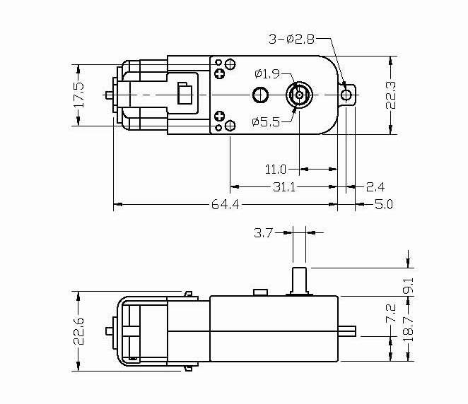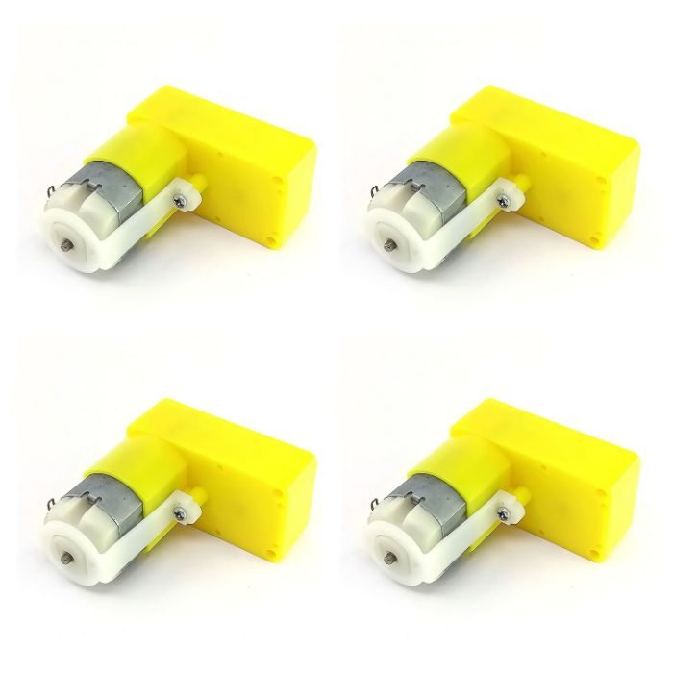

**3.5 Shaft Battery Operated Motor**

**SERVO MOTOR SG-90**

The SG-90 servo motor plays a pivotal role in providing precise and controlled motion to specific components. The SG-90 is a popular and widely used micro-sized servo motor known for its accuracy and reliability. Its primary function in the project is to offer controlled angular displacement to various mechanical parts or elements. By interfacing with a microcontroller or control system, the SG-90 servo motor receives signals that dictate its exact position and angle.

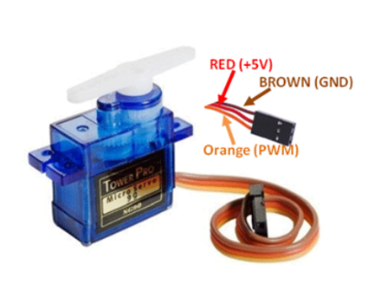This level of precision is invaluable for applications that require fine-tuned movements, such as robotic arms, camera gimbals, or remote-controlled mechanisms. The SG-90's compact size and lightweight construction make it ideal for projects where space and weight constraints are critical considerations. Whether it's ensuring a camera remains steady, controlling the movement of a drone's control surfaces, or automating the positioning of sensors, the SG-90 servo motor contributes to the project's success by delivering controlled and accurate motion.

**3.6 Servo Motor SG-90**

**18650 BATTERY**

First why this name 18650 - An 18650 battery is a lithium-ion battery. The name derives from the battery's specific measurements: 18mm x 65mm.

Many electronics and motors, including those used in autonomous car projects, require a voltage higher than the 3.7V provided by a single 18650 cell. By connecting two 18650 cells in series, you effectively double the voltage to 7.4V (assuming each cell is 3.7V). This higher voltage can provide the necessary power to drive motors and other components. It offers the advantages of higher voltage, energy density, and rechargeability while being readily available in the market.

The 18650 battery holds a pivotal role in our autonomous car project as it serves as the energy source to power the vehicle's components. These lithium-ion batteries are known for their high energy density, compact size, and rechargeable nature, making them an ideal choice for our portable autonomous car. They provide the necessary electrical power to drive the motors, Arduino microcontroller, and all the onboard sensors. With their capacity to store a substantial amount of energy, 18650 batteries ensure extended operational periods for our autonomous car, allowing it to navigate and execute tasks efficiently. In a project where continuous operation is essential, these batteries are not only reliable but also practical, as they can be recharged for extended use, thus providing a sustainable and robust power solution for our autonomous vehicle.

**CHAPTER 4**

**Driving Intelligence: Motor Control and Sensor Integration**

**4.1 SENSOR SELECTION AND INTEGRATION**

The selection and integration of sensors are paramount in the development of our autonomous car prototype. These sensors serve as the car's sensory organs, providing the critical data it needs to navigate its environment, make decisions, and perform specific tasks. In our project, we have carefully chosen a combination of ultrasonic sensors, infrared sensors, and cameras to create a comprehensive perception system.

**Ultrasonic Sensors**: Ultrasonic sensors operate on the principle of emitting high-frequency sound waves and measuring the time it takes for these waves to bounce back after hitting an object. The time delay is directly proportional to the distance to the object, allowing the sensor to calculate the object's proximity. Ultrasonic sensors are invaluable for obstacle detection. When an object or obstacle is within a predefined range, the sensor detects it, providing crucial data for the car to respond. These sensors are highly effective for detecting solid objects and are widely used in applications such as parking assist systems in automobiles.

**Infrared Sensors**: Infrared sensors are another essential component of our perception system. They work based on the reflection of infrared light from objects. By analyzing the reflected light, the sensor can determine the presence of an object in its field of view. In our autonomous car project, infrared sensors complement the ultrasonic sensors by providing close-range proximity detection. While ultrasonic sensors are excellent for detecting objects at a distance, infrared sensors are more suitable for identifying objects in proximity. This combination of long-range and short-range sensors ensures comprehensive obstacle detection and enhances safety during navigation.

**4.1 Block Diagram of the Sensor Methodology**

**Integration**: The integration of these sensors into our autonomous car project is a multi-faceted process that begins with the physical mounting of the sensors on the car's chassis. Each sensor is strategically positioned to provide optimal coverage of the car's surroundings. Ultrasonic sensors are typically placed at the front, rear, and sides of the vehicle to detect objects in these directions. Infrared sensors, with their shorter range, are often situated in closer proximity to the car's body to detect objects near the ground or immediate surroundings. Cameras are usually mounted at the front or rear of the car, facing the road and surroundings.

Once the sensors are physically mounted, they are connected to the Arduino microcontroller. The Arduino serves as the central processing unit, collecting data from the sensors and processing it in real-time. It runs algorithms that have been specifically designed for tasks such as obstacle avoidance, line following, and object recognition. The Arduino processes the sensor data to make critical decisions for the car's navigation and operation. For instance, when an ultrasonic sensor detects an obstacle within a certain range, the Arduino can trigger the car to slow down, change direction, or stop to avoid a collision. Similarly, the cameras provide visual input that Arduino analyzes to identify lane markings and make decisions about steering and staying within the designated path. The integration of sensors is seamless and interactive. The sensors continuously feed data to the Arduino, which responds to this data in real-time, creating a closed-loop system. This allows the car to dynamically adjust its behavior based on the information received from the sensors. The synergy between sensor data, processing by the Arduino, and the control logic is what enables our autonomous car to perform its intended tasks efficiently and safely. The integration process is not limited to hardware connections. It also involves software development. The Arduino microcontroller is programmed to handle the data from the sensors and execute the algorithms for autonomous navigation. This software integration is where the "intelligence" of the autonomous car resides. The Arduino processes the sensor data, interprets it, and executes control actions. This may involve sending commands to the car's motors to adjust speed or direction, all based on the information received from the sensors.

The selection and integration of sensors are fundamental to the success of our autonomous car project. The combination of ultrasonic sensors, infrared sensors, and cameras creates a robust perception system that enables the car to navigate, avoid obstacles, follow lines, and interact with its environment. The seamless integration of these sensors into the project, both in terms of hardware connections and software development, is what empowers our autonomous car to operate efficiently and safely in its autonomous mode. It's this fusion of technology that forms the foundation of autonomous vehicle systems, offering a glimpse into the future of transportation and the possibilities of smart and self-driving vehicles.

**4.2 MOTOR CONTROL**

Motor control is a pivotal element in the successful operation of our autonomous car prototype. It directly influences the vehicle's movement, steering, and the execution of essential tasks like obstacle avoidance and line following. In this detailed explanation, we will delve into the specifics of how we control the motors for movement, encompassing motor driver selection and the intricacies of wiring.

**Motor Selection:** The selection of motors for our autonomous car project is a critical consideration. We require motors that are not only reliable but also capable of precise control. The choice of motors depends on the specific requirements of the autonomous car, including factors such as size, power, and efficiency. In our project, we opted for DC (Direct Current) motors due to their suitability for small-scale vehicles. These motors offer simplicity, ease of control, and compatibility with a wide range of motor drivers. They also exhibit the durability needed for continuous operation, which is essential for our project's functionality.

**Motor Drivers:** To control the DC motors effectively, we use motor drivers. Motor drivers are crucial components that interface between the microcontroller, in our case, the Arduino, and the motors themselves. They enable precise control of motor speed and direction. We chose a dual H-bridge motor driver, specifically the L298N, for our project. The L298N is a popular and versatile motor driver that can handle two motors independently. It provides bidirectional control, meaning it can drive the motors forward and backward. Moreover, the L298N can handle higher currents, which is beneficial for powering the motors in our autonomous car, especially when they need to overcome obstacles or maintain a consistent speed.

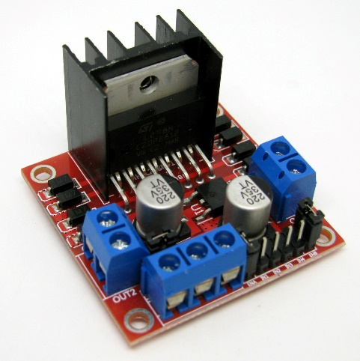**Wiring and Connections:** Wiring is a crucial part of the motor control system. The L298N motor driver is connected to the Arduino microcontroller and the motors through a series of wires. The wiring setup is as follows:

**4.1 L298N MOTOR DRIVER**

**1. Motor Connections**: The DC motors are connected to the output terminals of the L298N motor driver. Two wires from each motor are connected to the motor driver. Each motor has two terminals: one for positive and one for negative. The polarity determines the direction of the motor. By controlling the voltage and polarity applied to these terminals, we can make the car move forward, backward, turn left, or turn right.

**2. Power Supply:** The motor driver also requires a power supply to operate. We provide a separate power source, typically a battery pack, to power the motors. This is essential because motors can draw high currents that could potentially disrupt the operation of the Arduino if powered from the same source. It's important to ensure that the power supply voltage matches the motor specifications and the motor driver's capabilities.

**3. Arduino Connections:** The Arduino microcontroller is connected to the L298N motor driver through various pins. Typically, the connections include:

- Two digital pins on the Arduino for controlling the motor driver's input to set motor direction (e.g., one pin for forward and one pin for backward).

- Two other digital pins for controlling the motor driver's input to set motor speed (e.g., one for increasing speed and one for decreasing speed).

- Ground (GND) connections between the Arduino, motor driver, and the external power supply to establish a common ground reference.

- Additionally, a 5V output from the Arduino can power the motor driver's control logic.

The actual wiring can get more intricate depending on the specific hardware setup and the number of motors used in the autonomous car. Properly securing and insulating the wires is essential to avoid interference or short circuits, ensuring the reliability and safety of the entire system.

**Control Logic:** The control logic for the motors is implemented in Arduino’s code. The Arduino microcontroller receives input from various sensors, including ultrasonic, infrared, and cameras, which inform the car about its environment. The code processes this sensor data and makes real-time decisions regarding motor control. For instance, when an obstacle is detected by the ultrasonic sensor, the Arduino instructs the motor driver to halt the motors or adjust their speed and direction to navigate around the obstacle. Similarly, during line following, the Arduino ensures that the motors respond appropriately to keep the car on the desired path.

Motor control in our autonomous car project is a multifaceted process involving the selection of suitable DC motors, the use of a dual H-bridge motor driver (L298N) for precise and bidirectional control, and the establishment of a systematic wiring and connection scheme. This system enables the car to move, steer, and execute specific tasks autonomously. The motor control logic, implemented in the Arduino's code, is the linchpin that interprets sensor data and orchestrates the motors' actions, ensuring the vehicle's ability to navigate its environment effectively and safely. The synergy between sensor input, control logic, and motor response constitutes the core of our autonomous car's functionality.

**4.3 OBSTACLE AVOIDANCE ALGORITHM**

The obstacle avoidance algorithm is a pivotal component of our autonomous car project, enabling the vehicle to navigate safely by detecting and circumventing obstacles in its path. To achieve this, we have developed a comprehensive algorithm that encompasses various sensors and control logic, ensuring that the car makes informed decisions in real-time.

**Sensor Data Integration**: The algorithm begins with the integration of data from our suite of sensors. Ultrasonic sensors are the primary source of information for obstacle detection. These sensors continuously emit high-frequency sound waves and measure the time it takes for these waves to bounce back after hitting an object. This data is processed by the Arduino microcontroller in real-time. As the car moves, the ultrasonic sensors continuously collect distance measurements to objects in front, behind, and to the sides of the vehicle. The algorithm relies on this data to make decisions about whether to slow down, change direction, or stop altogether to avoid collisions.

**Decision-Making Logic**: The heart of the obstacle avoidance algorithm lies in the decision-making logic. It's a dynamic process that assesses the incoming sensor data and responds accordingly. The key components of this logic include:

**1. Thresholds and Ranges:** We set predefined distance thresholds for the ultrasonic sensors. When an object is detected within a certain range, the algorithm triggers a response. For example, if an obstacle is detected within a short range, the car might need to stop, while if the obstacle is detected at a greater distance, the car may simply slow down or make a slight course adjustment.

**2. Obstacle Identification:** The algorithm doesn't just rely on proximity but also considers the angle and location of detected obstacles. By interpreting which sensors detected the obstacle and their relative positions, the algorithm can determine the obstacle's direction in relation to the car. This information is crucial for decision-making. For instance, if an obstacle is detected directly in front, the car might need to stop or navigate around it, but if the obstacle is detected to the side, a simple steering adjustment might suffice.

**3. Smooth Movement:** To ensure a smooth and natural response, the algorithm incorporates gradual deceleration and acceleration profiles. Sudden stops or sharp turns can be jarring, so we've programmed the car to gradually slow down or make smooth steering adjustments to avoid abrupt maneuvers.

**4. Path Planning:** In complex scenarios with multiple obstacles, the algorithm employs basic path planning. It calculates the optimal path for the car to navigate around the obstacles while staying on course. This might involve a combination of slowing down, changing direction, and maintaining a safe distance from obstacles.

**Pseudocode:**

while car_is_operating:

ultrasonic_data = read_ultrasonic_sensors()

for sensor in ultrasonic_data:

if obstacle_detected(sensor):

distance = get_distance(sensor)

if distance < short_range_threshold:

stop_car()

elif distance < medium_range_threshold:

slow_down_car()

else:

adjust_course()

plan_optimal_path()

else:

continue_on_current_path()

In this pseudocode, the algorithm iterates through the ultrasonic sensor data, checks for obstacle detection, and decides the appropriate action based on the detected obstacle's range. The car's response varies from stopping to slowing down or adjusting its course, depending on the obstacle's proximity.

The actual code implementation is more complex and involves real-time data processing and communication with the motor control system. However, this pseudocode provides a simplified representation of the algorithm's decision-making logic. Our obstacle avoidance algorithm is a dynamic and adaptable system that relies on a combination of sensor data, predefined thresholds, and real-time decision-making logic to ensure the autonomous car navigates its environment safely. It's a fundamental component that guarantees the vehicle's ability to respond to changing situations and steer clear of obstacles, thus promoting safety and autonomy.

**4.4 LINE FOLLOWING ALGORITHM**

The line-following algorithm is a crucial component of our autonomous car project, allowing the vehicle to autonomously trace and adhere to predefined paths or road markings. This algorithm is founded on the integration of sensors, control logic, and real-time decision-making. Below, we will detail how our car can effectively follow lines or paths and provide an overview of the strategies and code used for this purpose.

**Sensor Integration:** The key to line following is the integration of sensors that can detect and interpret the path or line on which the car should travel. In our project, we employ infrared sensors for this task. These sensors are positioned beneath the car's chassis and emit infrared light onto the ground. They then measure the intensity of the reflected light. When the car is over a line, the infrared sensors detect a significant difference in the intensity of the reflected light compared to when it's over a contrasting surface. This data is sent to the Arduino microcontroller, which interprets it to make steering decisions.

**Control Logic and Decision-Making:** The line-following algorithm primarily relies on the control logic implemented in Arduino’s code. The algorithm's core components include:

**1. Error Calculation:** The algorithm calculates the error, which represents the deviation of the car from the center of the line. This is typically determined by comparing the sensor readings from the left and right infrared sensors. If the car is centered on the line, the error is zero. A positive error indicates that the car is veering to the right of the line, while a negative error indicates a deviation to the left.

**2. Proportional-Integral-Derivative (PID) Control:** A PID control algorithm is often employed to adjust the car's steering in real-time. The proportional component uses the error to calculate an immediate correction, the integral component accounts for accumulated errors over time, and the derivative component predicts future error changes. This PID control loop fine-tunes the car's steering to keep it aligned with the line. If the error is positive (the car is to the right of the line), the steering is adjusted to the left, and vice versa.

**3. Steering Adjustment:** Based on the PID control output, the algorithm adjusts the car's steering mechanism to ensure it remains on the line. If the error is zero, the car continues moving straight. If there is a positive error, the car steers slightly to the left, and if there is a negative error, it steers to the right. The degree of steering adjustment depends on the magnitude of the error, allowing the car to make gentle course corrections.

**Pseudocode:**

while car_is_operating:

left_sensor_value = read_left_infrared_sensor()

right_sensor_value = read_right_infrared_sensor()

error = left_sensor_value - right_sensor_value

proportional = Kp * error

integral += Ki * error

derivative = Kd * (error - previous_error)

steering_adjustment = proportional + integral + derivative

previous_error = error

adjust_steering(steering_adjustment)

move_forward()

In this pseudocode, the algorithm reads sensor data from the left and right infrared sensors, calculates the error, and applies a PID control loop to determine the steering adjustment. The steering adjustment is then applied to keep the car following the line.

While this pseudocode provides a simplified representation of the algorithm, the actual implementation involves real-time data processing, fine-tuning of PID control constants (Kp, Ki, and Kd), and communication with the motor control system to adjust the car's steering.

**Strategies:**

Several strategies and considerations are essential for effective line following:

**i. Calibration:** The sensors need to be calibrated to distinguish between the line and the background surface. This calibration ensures that the car correctly identifies the line and can respond accurately.

**ii. PID Tuning:** Proper tuning of the PID constants is crucial for smooth and precise line following. These constants need to be adjusted to optimize the car's response to errors and ensure it follows the line without excessive oscillations.

**iii. Line Detection:** Depending on the complexity of the path or line to be followed, the algorithm may need to be capable of handling both simple single-line scenarios and more intricate maze-like paths. The strategy for detecting the line and making decisions may vary accordingly.

**iv. Adaptive Control:** In some situations, adaptive control strategies are used, where the car dynamically adjusts its speed or steering based on the curvature of the line or the complexity of the path.

Line-following algorithm is a sophisticated system that relies on infrared sensor data, control logic, and real-time decision-making to enable the autonomous car to effectively follow lines or paths. It encompasses error calculation, PID control, and steering adjustment, all of which work in harmony to keep the car aligned with the desired trajectory. The actual code implementation is more intricate and includes factors such as calibration, PID tuning, and adaptive control strategies, all of which contribute to the car's ability to autonomously follow lines and paths with precision and reliability.

**CHAPTER 5**

**WIRELESS COMMUNICATION AND POWER SUPPLY MANAGEMENT**

**5.1 INTRODUCTION**

Wireless control mechanisms, like Bluetooth, play a pivotal role in modern technology, and they are especially crucial in cutting-edge applications like autonomous vehicles. In this discussion, we'll explore how Bluetooth can be utilized in an Arduino-based prototype model of an autonomous car, highlighting its role in both remote control and monitoring of this advanced system.

Bluetooth technology, known for its versatility, low power consumption, and relative simplicity, offers an excellent solution for establishing wireless communication between an autonomous vehicle and a remote-control interface. This technology has been widely adopted in various applications and is particularly well-suited for scenarios where the seamless exchange of data, commands, and real-time feedback is essential.

**5.2 Utilizing Bluetooth in an Arduino-Based Autonomous Car Prototype**

In an Arduino-based autonomous car prototype, Bluetooth modules can be employed to facilitate remote control and monitoring through a smartphone or computer interface. Let's delve into how Bluetooth integration can make this project a reality.

**Wireless Remote Control:** Bluetooth serves as the bridge between the user and the autonomous car. Through a dedicated smartphone application or a computer interface, users can send commands to the car via Bluetooth. These commands can include instructions for starting, stopping, turning, or changing speed, making Bluetooth a crucial element in achieving remote control of the autonomous vehicle. For instance, when you want the car to start moving, you can tap a button on your smartphone application. This command is transmitted via Bluetooth to the Arduino onboard the car, which interprets the command and initiates the appropriate actions, such as activating the motors to move the vehicle forward. The low-latency and reliability of Bluetooth connectivity are essential for ensuring that the vehicle responds promptly to the user's input.

**Data Acquisition and Monitoring:** Bluetooth also plays a pivotal role in collecting data from the autonomous vehicle and providing real-time feedback to the user. Various sensors and cameras on the car can capture information about the vehicle's surroundings, including distance to obstacles, speed, and GPS location. This data is transmitted to the user interface via Bluetooth.

Monitoring the car's performance and receiving crucial data is essential for making informed decisions. For example, if the car encounters an obstacle, sensors can detect it, and the data is sent through Bluetooth to the user's interface, alerting the user to the obstacle's presence. The user can then decide whether to instruct the car to stop or change its course.

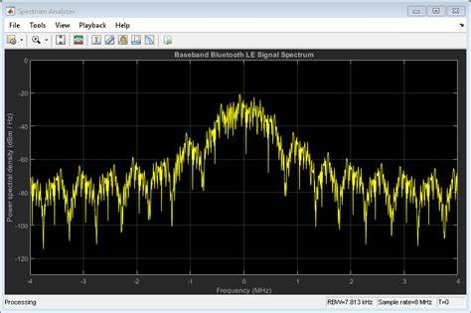

**5.1 Bluetooth Waveform Generation and Transmission Spectrum**

**Sensor Integration:** In an autonomous car project, sensors are the eyes and ears of the vehicle, enabling it to perceive and react to its environment. Bluetooth technology can be used to integrate various sensors, such as ultrasonic distance sensors, infrared sensors, and cameras, into the system. These sensors provide critical data for obstacle detection, lane following, and other essential functions of an autonomous vehicle. Ultrasonic sensors can measure distances to objects in the car's path, ensuring that it maintains a safe distance from obstacles. The data collected by these sensors can be continuously transmitted to the Arduino on the car via Bluetooth. This real-time information allows the vehicle to make rapid decisions and navigate effectively.

**Bluetooth Modules for Communication:** To achieve wireless communication between the Arduino onboard the autonomous car and the user interface, Bluetooth modules like the HC-05 or HC-06 can be employed. These modules are readily available and cost-effective, making them popular choices for hobbyist and prototype projects. Bluetooth module on the car can establish a connection with the Bluetooth module on the user's smartphone or computer. This connection forms the communication link through which commands and data are exchanged.

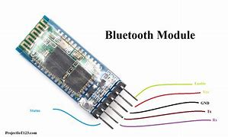

**5.2 Bluetooth Module**

**Smartphone Application for User Control:** The user control aspect of the project can be implemented through a custom smartphone application. This app can be designed to send commands to the autonomous car via Bluetooth. Users can select the car's mode (e.g., autonomous, manual control) and issue specific commands, such as starting or stopping the car, changing its direction, or adjusting its speed.

Additionally, the smartphone application can provide a user-friendly interface for monitoring the car's sensor data and receiving feedback in real-time. Visualizing data from the car's sensors, such as distance measurements, GPS coordinates, or camera feeds, can be instrumental in ensuring that the car operates safely and efficiently.

**Data Logging and Analysis**: Beyond real-time monitoring, Bluetooth can also be utilized for data logging and analysis. The Arduino on the autonomous car can store sensor data and other pertinent information, periodically transmitting it to the user interface for analysis. This historical data can be valuable for troubleshooting, performance optimization, and making necessary adjustments to the autonomous car's algorithms and behavior.

Moreover, it can be used for post-mission analysis, helping users evaluate the car's performance and identify areas for improvement in future iterations.

**Security Considerations:**

Security is a critical aspect when implementing Bluetooth technology in an autonomous vehicle. Ensuring that the communication between the user interface and the vehicle is secure is paramount. Using secure authentication and encryption protocols is essential to prevent unauthorized access or interference with the vehicle's control.

Bluetooth technology offers a versatile and efficient solution for both remote control and monitoring in an Arduino-based autonomous car prototype. The seamless integration of Bluetooth modules, sensor data, and a user-friendly smartphone application provides users with a powerful and intuitive means to interact with the autonomous vehicle, making it an ideal choice for hobbyist projects and educational demonstrations in the field of autonomous robotics and vehicles. With the rapid development of wireless communication technologies, the possibilities for creating innovative and sophisticated autonomous systems are continually expanding, and Bluetooth is a key enabler in this exciting realm of technology.

**5.3 ENERGIZING AUTONOMY: POWER SUPPLY AND BATTERY CONFIGURATION**

In autonomous vehicles, efficient power supply and battery management are paramount. An autonomous car powered by an Arduino-based system relies on a well-designed electrical setup to ensure continuous, uninterrupted operation. This discussion delves into the intricacies of powering an autonomous car, the critical considerations for managing power, and the battery setup that ensures smooth, extended operation.

**Power Supply and Autonomous Cars:**

Powering an autonomous car, be it a prototype or a fully-fledged vehicle, is a multifaceted challenge. These vehicles typically consist of various components, including microcontrollers, sensors, motors, and communication modules. These components demand different voltage levels and power requirements, necessitating a carefully designed power supply system.

**5.3 Circuit Diagram of the Design**

**Power Considerations for Continuous Operation:**

Continuous operation is a primary concern for autonomous cars, particularly for applications like self-driving vehicles, surveillance drones, or remote sensing systems. In these scenarios, the car must operate for extended periods without interruption, making power considerations crucial.

i. Voltage and Current Requirements:

To meet the diverse power needs of the car's components, a well-regulated power supply system is essential. Voltage regulators ensure that each component receives the appropriate voltage, preventing damage and optimizing performance. Furthermore, a robust current supply is necessary to accommodate peak power demands, such as when the car accelerates or activates multiple sensors simultaneously.

ii. Battery Selection and Capacity:

The choice of battery and its capacity significantly impacts an autonomous car's operational duration. Battery capacity is typically measured in ampere-hours (Ah) or milliampere-hours (mAh). Larger capacity batteries can store more energy, enabling the car to run for longer periods. However, this comes at the cost of increased weight and size, which can affect the car's mobility.

iii. Battery Chemistry:

Selecting the appropriate battery chemistry is essential. Lithium-ion (Li-ion) and lithium-polymer (LiPo) batteries are common choices for autonomous car projects due to their high energy density and relatively low weight. These batteries offer a good balance between capacity and weight, making them suitable for prolonged operation.

iv. Charging Mechanism:

Ensuring a convenient and efficient charging mechanism is crucial. Some autonomous cars are equipped with onboard charging systems, while others may rely on removable batteries. The charging method should be user-friendly and capable of recharging the batteries quickly, minimizing downtime.

v. Redundancy and Backup Power:

For mission-critical applications, redundancy in the power supply system is advisable. This can involve multiple batteries, redundant voltage regulators, or even backup power sources such as supercapacitors. Redundancy ensures that the car can continue operating even if one component or power source fails.

vi. Power Monitoring and Management:

Implementing a robust power monitoring and management system is vital for an autonomous car. This includes the ability to track battery voltage, current consumption, and remaining capacity. Additionally, the car's control system should be able to respond to low battery warnings by returning to a charging station or taking other pre-defined actions to ensure continued operation.

**5.4 Battery Setup for Autonomous Cars:**

The battery setup for an autonomous car involves several critical components and considerations to ensure reliable and continuous operation.

Battery Configuration: Depending on the power requirements and design constraints, the batteries can be configured in various ways. Series and parallel connections are common methods to achieve the desired voltage and capacity. The choice of configuration depends on the specific voltage and current demands of the car's components.

Voltage Regulation: Voltage regulation is necessary to provide stable voltage levels to the car's electronic components. Voltage regulators are employed to step down the voltage from the battery to match the requirements of the microcontrollers, sensors, and other onboard devices. These regulators help prevent over-voltage, which can damage sensitive electronics.

Current Protection: To safeguard the car's components from excessive current, current protection mechanisms such as fuses, and circuit breakers are integrated into the electrical system. These devices trip in the event of a current overload, preventing damage to the car's components.

Battery Management System (BMS): In the context of rechargeable lithium-ion or lithium-polymer batteries, a Battery Management System (BMS) is often used to monitor and balance individual cells. A BMS helps protect the battery from overcharging, over-discharging, and thermal issues. It also ensures that each cell within the battery pack operates within safe voltage limits.

Charging Infrastructure: Autonomous cars require a reliable and efficient charging infrastructure. For projects that involve removable batteries, charging stations with appropriate connectors and charging controllers can be designed. Onboard charging solutions are also possible, but they should be user-friendly and compatible with commonly available power sources.

Energy-Efficient Components: Selecting energy-efficient components, including microcontrollers, sensors, and motors, can significantly extend the operational duration of the autonomous car. Lower power consumption reduces the load on the batteries and allows for longer missions.

Dynamic Power Allocation: Implementing a dynamic power allocation system enables the car to prioritize power distribution to components that are actively in use. For instance, when the car is stationary, it may allocate more power to sensors for data acquisition and processing, reserving energy for propulsion when needed.

**5.5 Challenges in Powering Autonomous Cars:**

Several challenges must be addressed when designing the power supply and battery setup for autonomous cars. These challenges include:

**Weight vs. Capacity Trade-off:**

Balancing battery capacity with the weight of the batteries is a significant challenge. Larger capacity batteries offer longer operational durations but can make the car heavier, potentially affecting its mobility and maneuverability.

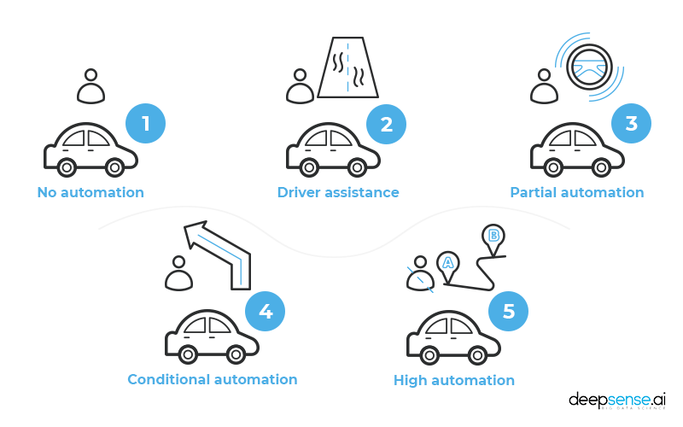

**5.4 Tackling the Challenges of the Autonomous car**

**Temperature Considerations:**

Lithium-based batteries are sensitive to temperature. Extreme heat or cold can affect their performance and longevity. Thus, managing the temperature of the battery pack is essential for sustained operation.

**User Interface and Monitoring:**

Providing users with a clear interface for monitoring the battery's state of charge, remaining run-time, and charging status is essential for a positive user experience. Effective user feedback ensures that the car can be operated efficiently and prevents premature battery exhaustion.

Efficient power supply and battery management are critical aspects of autonomous car projects using Arduino-based systems. A carefully designed power system ensures that the car can operate continuously, meeting the demands of various applications, from self-driving vehicles to surveillance drones and remote sensing platforms. By addressing voltage regulation, battery selection, charging infrastructure, and other key considerations, developers can create autonomous cars that are reliable, adaptable, and capable of extended operation in a variety of scenarios.

**CHAPTER 6**

**PERFORMANCE AND RESULT**

The development of an autonomous car using Arduino is a complex endeavor that demands meticulous testing and troubleshooting. These processes are vital to ensure that the system performs its intended tasks reliably and safely. In this discussion, we'll delve into the comprehensive testing methodology employed in the project, address some of the issues encountered during development, and assess the results and performance of the prototype, including the integration of real-world data where applicable.

**6.1 Testing Methodology:**

The development of an autonomous car is an intricate task that necessitates a systematic approach to testing. The testing methodology employed in this project was multifaceted, encompassing several key components. Firstly, rigorous hardware testing was conducted. This involved individual testing of hardware components such as sensors, actuators, motors, and the Arduino microcontroller to ensure their proper functionality. Each component's role in the autonomous car's operation was tested, from sensors accurately measuring distances to cameras capturing images, motors responding to control commands, and the Arduino effectively communicating with all other components. sensor calibration was another pivotal aspect of the testing process. Ultrasonic distance sensors required calibration to provide accurate distance measurements, ensuring reliable obstacle detection. Cameras, which are integral for perceiving the car's environment, needed precise calibration to ensure that images were captured with the correct perspective and orientation.

Simulations played a significant role in the testing methodology. These virtual environments allowed for the mimicking of real-world scenarios and the testing of the autonomous car's algorithms before real-world implementation. This approach aided in early identification and resolution of issues, enabling a more efficient development process.

Controlled environment testing was a crucial step, which involved deploying the autonomous car in confined and controlled spaces. This was essential for observing the car's behavior and assessing its basic functionalities, such as obstacle avoidance, path following, and responsiveness to remote control commands. Such controlled scenarios provided a safe environment to evaluate fundamental operations before venturing into more complex real-world tests.

Real-world testing was the ultimate validation step. It involved taking the prototype to different locations and testing its performance under various conditions, such as different terrains, lighting conditions, and obstacle densities. Real-world testing provided invaluable insights into the car's performance and was instrumental in assessing how well it could adapt to unpredictable, dynamic environments.

**6.1 Flow Chart of the system**

**6.2 Issues Encountered and Resolutions:**

The development of an autonomous car prototype is not without its challenges. Throughout the testing phases, several issues were encountered, but each presented an opportunity for creative problem-solving:

One of the primary challenges faced was sensor interference. In real-world environments, sensors could experience interference, leading to inaccurate distance measurements. To address this, sensor fusion techniques were employed. These techniques combined data from multiple sensors, filtered out noisy data, and improved obstacle detection reliability. Sensor fusion significantly enhanced the car's ability to make informed decisions based on more accurate environmental data.

Algorithm optimization was another critical aspect. Initial algorithms sometimes struggled with real-time decision-making, causing the car to make suboptimal choices in complex scenarios. Addressing this challenge involved continuous fine-tuning and optimization of algorithms to improve decision accuracy and reaction times. Algorithms were refined to enable the car to make more efficient and context-aware choices, particularly in dynamically changing environments.

Power management presented a distinct challenge. To ensure uninterrupted power supply for continuous operation, efficient battery management was crucial. Battery management issues were addressed by introducing a dynamic power allocation system. This system prioritized power distribution to essential components when needed, effectively extending operational duration. By allocating power intelligently, the car could maximize its endurance and continue its missions for longer periods. communication stability was another issue that required attention. Bluetooth communication between the car and the remote-control interface sometimes suffered from interference in crowded wireless environments. This was mitigated by enhancing the communication protocol and increasing error handling capabilities to maintain stable connections. This was particularly important for the remote-control functionality, ensuring that users could confidently and effectively command the car's actions.

**6.3 Results and Performance:**

The prototype of the autonomous car using Arduino yielded promising results in various testing scenarios. The car demonstrated effective obstacle avoidance capabilities, reliably detecting and steering clear of obstacles in its path. The combination of ultrasonic sensors, algorithm optimization, and dynamic power allocation allowed the car to navigate environments with a high degree of accuracy. Path following, a crucial aspect of autonomous navigation, was successfully implemented. The car was able to follow predefined paths and adjust its trajectory as needed, ensuring it stayed on course. This feature is particularly essential for applications where the car must follow a specific route or path for data collection or surveillance.

Real-world testing played a pivotal role in assessing the car's performance under different conditions. The data collected during these real-world tests included obstacle detection rates, response times, and path-following accuracy. This real-world data allowed for more comprehensive analysis and further refinement of the car's algorithms.

The remote-control functionality, integrated via Bluetooth communication, offered a responsive and user-friendly means of commanding the car's actions. Users could easily control the car's movements, switch between autonomous and manual modes, and receive real-time feedback through the smartphone application. This feature enhanced the car's versatility, making it suitable for various applications that require user interaction or intervention.

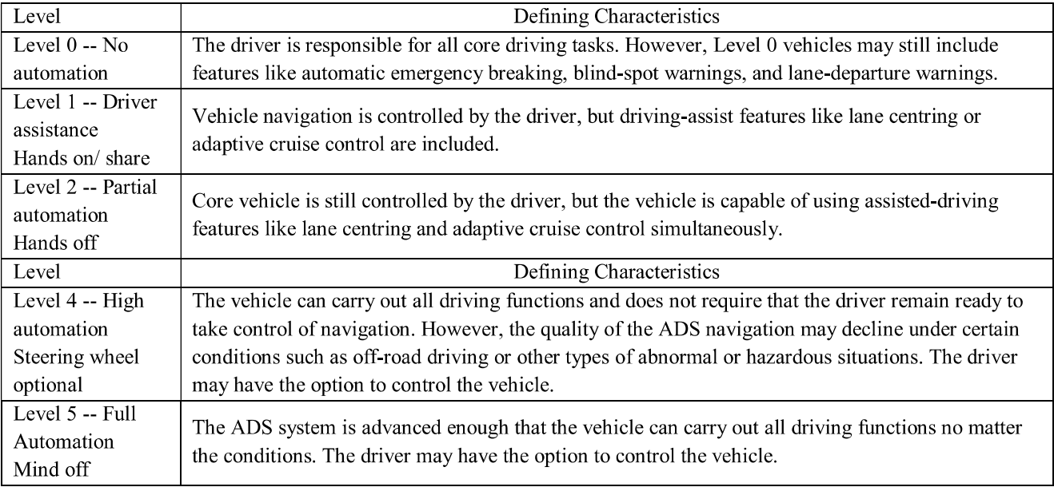

**6.2** **Levels of automations and its characteristics**

Endurance and continuous operation were key performance metrics. The car demonstrated impressive endurance, with the optimized power management system extending its operational durations. This was crucial for applications requiring prolonged missions, such as surveillance, data collection, or exploration. The car proved its ability to operate continuously for extended periods, making it a reliable choice for various autonomous tasks.

**6.4 Coding**

//Bluetooth control RC car

//

//Before uploading the code you have to install the "Adafruit Motor Shield" library

//Open Arduino IDE >> Go to sketch >> Include Libray >> Manage Librays... >> Search "Adafruit Motor Shield" >> Install the Library

//AFMotor Library: https://learn.adafruit.com/adafruit-motor-shield/library-install

//******* please diconnect the Rx Tx wires form Bluetooth module when youare downloading the code ******

#include <AFMotor.h>

// - initial motors pin

AF_DCMotor motor1(1, MOTOR12_1KHZ);

AF_DCMotor motor2(2, MOTOR12_1KHZ);

AF_DCMotor motor3(3, MOTOR34_1KHZ);

AF_DCMotor motor4(4, MOTOR34_1KHZ);

char command;

int t=0;

void setup()

{

Serial.begin(9600); //Set the baud rate to your Bluetooth module.

}

void loop(){

if(Serial.available() > 0){

command = Serial.read();

Stop(); //initialize with motors stoped

//Change pin mode only if new command is different from previous.

Serial.println(t);

switch(command){

case 'F':

forward();

break;

case 'B':

back();

break;

case 'L':

left();

break;

case 'R':

right();

break;

case '1':

t=25;

break;

case '2':

t=50;

break;

case '3':

t=75;

break;

case '4':

t=100;

break;

case '5':

t=125;

break;

case '6':

t=150;

break;

case '7':

t=175;

break;

case '8':

t=200;

break;

case '9':

t=225;

break;

case 'q':

t=255;

break;

}

}

}

void forward()

{

Serial.println("FW");

Serial.println(t);

motor1.setSpeed(t); // velocity

motor1.run(FORWARD); //rotate the motor clockwise

motor2.setSpeed(t); // velocity

motor2.run(FORWARD); //rotate the motor clockwise

motor3.setSpeed(t); // velocity

motor3.run(FORWARD); //rotate the motor clockwise

motor4.setSpeed(t); // velocity

motor4.run(FORWARD); //rotate the motor clockwise

}

void back()

{

Serial.println("BW");

Serial.println(t);

motor1.setSpeed(t); // velocity

motor1.run(BACKWARD); //rotate the motor anti-clockwise

motor2.setSpeed(t); // velocity

motor2.run(BACKWARD); //rotate the motor anti-clockwise

motor3.setSpeed(t); // velocity

motor3.run(BACKWARD); //rotate the motor anti-clockwise

motor4.setSpeed(t); // velocity

motor4.run(BACKWARD); //rotate the motor anti-clockwise

}

void left()

{

Serial.println("L");

Serial.println(t);

motor1.setSpeed(t); // velocity

motor1.run(BACKWARD); //rotate the motor anti-clockwise

motor2.setSpeed(t); // velocity

motor2.run(BACKWARD); //rotate the motor anti-clockwise

motor3.setSpeed(t); // velocity

motor3.run(FORWARD); //rotate the motor clockwise

motor4.setSpeed(t); // velocity

motor4.run(FORWARD); //rotate the motor clockwise

}

void right()

{

Serial.println("R");

Serial.println(t);

motor1.setSpeed(t); // velocityvelocity

motor1.run(FORWARD); //rotate the motor clockwise

motor2.setSpeed(t); // velocity

motor2.run(FORWARD); //rotate the motor clockwise

motor3.setSpeed(t); // velocity

motor3.run(BACKWARD); //rotate the motor anti-clockwise

motor4.setSpeed(t); // velocity

motor4.run(BACKWARD); //rotate the motor anti-clockwise

}

void Stop()

{

Serial.println("S");

Serial.println(t);

motor1.setSpeed(0); // velocity

motor1.run(RELEASE); //stop the motor when release the button

motor2.setSpeed(0); //velocity

motor2.run(RELEASE); //rotate the motor clockwise

motor3.setSpeed(0); // velocity

motor3.run(RELEASE); //stop the motor when release the button

motor4.setSpeed(0); //velocity

motor4.run(RELEASE); //stop the motor when release the button

}

**6.5Challenges and Future Improvements:**

While the prototype performed well in most scenarios, there are still challenges and opportunities for improvement. The development of autonomous vehicles is an ongoing process, and continuous refinement is essential. Challenges that may be addressed in future iterations of the project include, refining decision-making algorithms for complex and dynamic environments is an ongoing task. While the car demonstrated effective obstacle avoidance and path following, more complex scenarios with dynamic obstacles or uncertain terrain may pose challenges that require further algorithmic enhancements. Achieving a higher level of autonomy and adaptability is a continuous goal.

Enhancing sensor reliability is another area of improvement. Autonomous cars heavily rely on sensor data for decision-making, and sensor accuracy is crucial. Research and development efforts can focus on improving sensor technology, reducing interference, and enhancing the precision of sensor measurements in various environmental conditions. further optimization of power management is essential for even longer missions. Innovations in energy-efficient components, battery technology, and power allocation strategies can lead to extended operational durations and increased autonomy for the car.

**CHAPTER 7**

**CONCLUSION**

**7.1 Improvements and Future Work:**

The development of an autonomous car using Arduino represents a significant milestone, but it is just the beginning of what can be achieved in the realm of autonomous robotics. The project's success has laid the foundation for future enhancements and expansions. Here, we suggest potential improvements and share our vision for the next steps.

i. Enhanced Autonomy:

One of the key areas for improvement is enhancing the car's autonomy. This involves further refining the decision-making algorithms to make the car more adaptive and capable in complex, dynamic environments. Advanced machine learning techniques, such as deep reinforcement learning, can be integrated to enable the car to learn from its experiences and make more informed decisions.

ii. Advanced Sensor Technology:

Improving sensor technology is a continuous effort. Integrating state-of-the-art sensors, such as LiDAR, high-resolution cameras, and advanced radar systems, can enhance the car's perception and obstacle detection capabilities. These sensors can provide a richer, more detailed understanding of the environment, enabling the car to navigate with higher precision.

iii. Localization and Mapping:

Developing robust localization and mapping solutions is critical. Implementing simultaneous localization and mapping (SLAM) techniques can help the car create accurate maps of its environment and determine its position with greater precision. This is particularly important for applications like autonomous transportation and delivery.

iv. Redundancy and Safety:

Redundancy is essential for safety. The addition of backup systems and sensors can provide fail-safes in case of component failure. This is vital for ensuring the safety of autonomous vehicles, especially in scenarios where human lives are at stake.

v. Connectivity and Communication:

Expanding the car's connectivity capabilities can facilitate remote monitoring, updates, and data sharing. Incorporating 5G technology and advanced communication protocols can enhance the car's ability to interact with other vehicles and infrastructure, contributing to the realization of smart transportation systems.

vi. Energy Efficiency:

Continuous improvement in energy efficiency is crucial. Research into lightweight materials, more efficient power management, and alternative energy sources, such as solar panels, can extend the car's operational range and reduce its environmental footprint.

vii. Integration of AI Assistants:

The integration of artificial intelligence (AI) assistants can enhance the user experience and interaction with the autonomous car. Voice commands, natural language processing, and machine learning algorithms can provide a more intuitive and user-friendly interface for controlling and interacting with the vehicle.

**7.2 Vision for the Next Steps:**

Looking forward, the vision for the next steps in the development of autonomous cars using Arduino is to continue pushing the boundaries of what is achievable in this field. We aim to see autonomous cars become an integral part of our daily lives, transforming transportation, logistics, and various industries. We envision a future where autonomous cars are not only practical but also safe, sustainable, and accessible to all, the next steps involve further research, development, and collaboration. Autonomous car technology should be advanced through interdisciplinary efforts, bringing together experts in robotics, artificial intelligence, sensor technology, and materials science. Partnerships with automotive companies, tech giants, and regulatory bodies can help bridge the gap between innovation and real-world deployment.

Soon, we anticipate seeing autonomous cars in public transportation systems, reducing traffic congestion, emissions, and accidents. We envision autonomous delivery vehicles making urban logistics more efficient and environmentally friendly. Additionally, we see autonomous cars playing a role in emergency response, where they can navigate disaster-stricken areas to assess and assist without putting human responders at risk. Moreover, we anticipate that autonomous cars will contribute to reducing the carbon footprint of transportation. Electric and self-driving vehicles can help mitigate the environmental impact of traditional combustion engine cars. As battery technology advances and charging infrastructure becomes more widespread, autonomous cars can play a pivotal role in the transition to sustainable and eco-friendly transportation solutions.

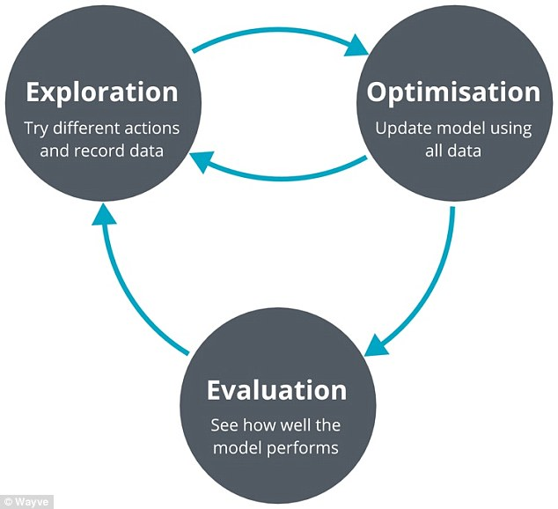

**7.1 Future Works**

**7.3 Charting the Path Ahead**

The project of developing an autonomous car using Arduino has showcased the immense potential of autonomous robotics and the pivotal role that Arduino technology can play in this domain. It is a testament to the creativity, innovation, and collaboration of the scientific and engineering community.

The achievement of this project underscores the importance of autonomous cars in our rapidly evolving world. These vehicles are not merely a technological curiosity but a tangible solution to some of the most pressing challenges of our time, including traffic congestion, environmental pollution, and the need for safer transportation. Autonomous cars promise to revolutionize our lives, making transportation more efficient, sustainable, and safe. Arduino, with its versatile microcontrollers and open-source ethos, has empowered inventors and developers to explore the possibilities of autonomous robotics. It has provided a platform for experimentation, learning, and innovation, democratizing access to cutting-edge technology.

In the years to come, the journey of autonomous cars using Arduino is destined to be marked by continuous advancement, refinement, and transformative impact. These vehicles hold the potential to redefine the way we move, work, and live. They represent the future of transportation, where technology and innovation come together to create safer, more efficient, and environmentally friendly solutions for our interconnected world.

**REFERENCES**

[1] Autonomous Car using Arduino Shambhavi Lalsinge, Yash Mali, Akshit Mahale, Mrunmayee Kulkarni, Omkar Kurade, Professor. Pramod Patil, (IRJET), Jan 2022.

[2] Line following robot using arduino, Md Takiul, Research Gate, 2019.

[3] Design and Construction of Line Following Robot using Arduino Khin Khin Saw, Lae Yin Mon, IJTSRD, 2019.

[4] Line Follower Using Arduino And Its Applications, Md Younus , Pooja Gadekar,Adhiraj Walse, Government College of Engineering Jalgaon, Maharashtra, 2019 IJAERV.

[5] Obstacle avoidance and path recognition of an

autonomous vehicle: A real implementation using

Arduino Uno, Mudita Dave, B.K. Sharma, Research Square 2022.

[6] Autonomous car using ultrasonic sensor & Arduino controller,

Kaushal Darji, Abdur Razzaq, Vinit Bhosale, Harshit Dubey, Manish Salvi.

[7] SELF DRIVING CAR PROTOTYPE, J. Gokul Raj, Prajakta R, Prasitha A, Shanthini B, Ravishankar S,

IRJETS,April 2024.

[8] Model of Autonomous Car, Uzma Kazi, Dr.Sharmila S. Gaikwad, Richa koli, Samishka Mhadeshwar, IRJET May-2020.

[9] A Self Driving Car using Machine Learning and IOT, Prof. Omprakash Yadav, Aman Sharma, Dion Philip, Boris Alexander, IJTRET August 2021.

[10] OBSTACLE DETECTION AND AVOIDANCE FOR AUTONOMOUS ELECTRIC VEHICLE USING ARDUINO, Shusmita M.Rathod, S. K. Apte, ijeast.com.